4.6 I can assess when there is a problem with collaborative technologies and when to get expert help

Running both desktop computers and mobile devices such as phones, laptops, tablets etc then you have to make sure that everything is working whilst using it, making sure your device is deemed worthy of working on the task you need to do. Is the power working? is that light on, does the microphone work? Can you record the part you need. Can you camera turn on? Can people see you in the meeting? Then making sure all your connectors is important as well so that you don’t run into any problems whilst working together.

While checking everything is working, you will most likely have to do an update to make sure the device gets the latest version, this could fix any problems you may be having or add the features that you need if you are looking for to make the project.

You may come into problems with running software on certain devices, most software works on Windows and Mac these days but Linux and other operating systems might still not have a way of working with them.

Most software may need a minimum requirement for running the software efficiently. This might mean you need a good graphics card or enough RAM.

If you have looked at all these problems then you may need to go to a forum and see if anyone else has the same issue or post a new forum post and ask someone if they know how to fix it. It might be unknown to the developer so you making the forum post might give the developer a reason to look at the issue and ship an update to fix the problem.

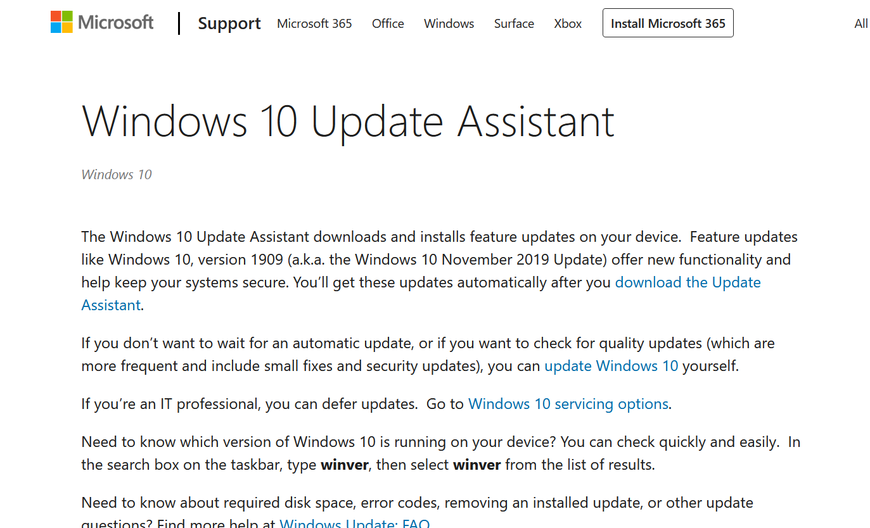

[The above image shows the Windows 10 Update Assistant which would help if you can’t do updates]

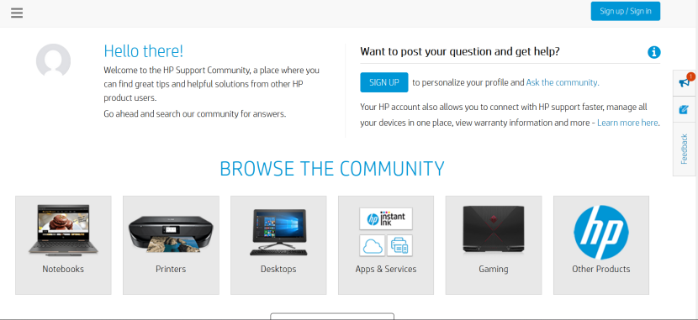

[The above image shows the HP Forum site where it has a list of different devices and sub-sections to get help from a HP product or service]